Sales Analysis Power BI MINI Project
Project Documentation

1. Business Scenario
A retail company has sales information coming from different sources. Management wants an interactive executive sales report that shows performance by region, product, customer, salesperson and time. The source data is not perfectly clean, so I first had to profile, clean, validate and model the data before creating the report.

2. Day 1 – Phase 1: Data Profiling and Power Query Cleaning

2.1 Understanding the Data
- I read the business scenario and understood it. The company has sales information from different sources, and management wants an interactive sales report showing performance by region, product, customer, salesperson and time.
- I cleaned and analysed all the data and then modelled it before creating the report.
- There are five datasets:
  - Customers
  - Employees
  - Products
  - Orders
  - Order_items
- The columns in each table are:
  - Customers: Customer ID, Name, Mail, City, Region
  - Employees: Employee ID, Employee Name, Role, Region, Manager_ID
  - Products: Product ID, Product Name, Category, Unit Price, Status
  - Orders: Order ID, Order Date, Customer ID, Salesperson ID
  - Order Items: OrderItem ID, Order ID, Product ID, Quantity, Unit Price, Revenue
- I observed that the Orders table has a relationship with Customer ID and Employee ID. The Order Items table has a relationship with Order ID and Product ID.

2.2 Customers Data
- I opened Power BI and used Get Data to load the Customers CSV file. Then I opened it in Transform Data.
- I checked the data types and column names. Both were correct.
Issue 1: Duplicate row
- Issue Found: One duplicate row was found.
- Affected Table/Column: Customers – all columns (Customer ID 1006, Ananya Singh, ananya.singh@example.com, Pune, west).
- Action Taken: I selected all columns using Shift + Right Arrow key and checked for duplicates. Then I used Remove Rows → Remove Bottom Rows and typed 1 as the number of rows.
- Reason/Assumption: The row was repeated, so only one copy was needed.
- Final Decision: Removed
Issue 2: Extra spaces and wrong capitalization in names
- Issue Found: There were many extra gaps (spaces) in the customer names and the names were not in a proper format.
- Affected Table/Column: Customers – Name.
- Action Taken: I used Trim and then Capitalize Each Word.
- Reason/Assumption: Names should be clean and in the same format.
- Final Decision: Corrected
Issue 3: Missing customer name
- Issue Found: At row 30 there was no customer name.
- Affected Table/Column: Customers – Name.
- Action Taken: I saw the name in the mail ID, so I used Replace Values to fill the blank with the name Lavanya K.
- Reason/Assumption: I did not want to delete the row because I would lose one customer's information. I assumed the name from the mail is the correct name.
- Final Decision: Corrected
Issue 4: Mail, Region and City formatting
- Issue Found: The mail, region and city values were not in a consistent format.
- Affected Table/Column: Customers – Mail, Region, City.
- Action Taken: For Mail I used Trim and lowercase. For Region and City I used Trim and Capitalize Each Word.
- Reason/Assumption: To keep the values consistent so that grouping and filtering work properly.
- Final Decision: Corrected
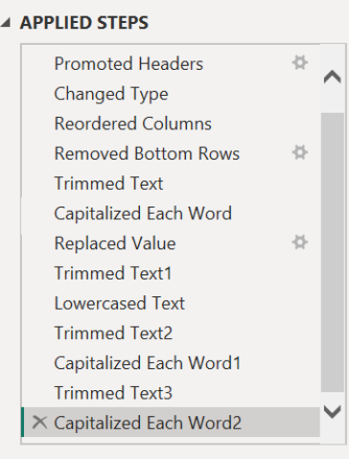
- Finally, I cleaned the Customers data and checked the data types again. They were correct. I clicked Close & Apply (Load and Apply) and renamed the table as customer_Data.

2.3 Employees Data
- I got the Employees table from Excel, clicked on the sheet and opened it in Power Query.
- The headers were not in the header row. I went to the Home ribbon and chose Use First Row as Headers, and the header names moved into the header place.
- The data types and column names were correct.
- I selected all columns and went to Home → Keep Rows → Keep Duplicates. I found no duplicates in this table. Then I went back by removing that step from Applied Steps.
Issue 1: Employee Name formatting
- Issue Found: Employee names were not in a clean format.
- Affected Table/Column: Employees – Employee Name.
- Action Taken: I used Trim and Capitalize Each Word.
- Reason/Assumption: To keep names clean and consistent.
- Final Decision: Corrected
Issue 2: Null value in Manager_ID
- Issue Found: Manager_ID has one null value.
- Affected Table/Column: Employees – Manager_ID.
- Action Taken: I checked the record. There is no reliable value to fill it with, so I kept the employee and left Manager_ID as null.
- Reason/Assumption: I did not want to delete the employee record, and I did not want to guess a value.
- Final Decision: Retained
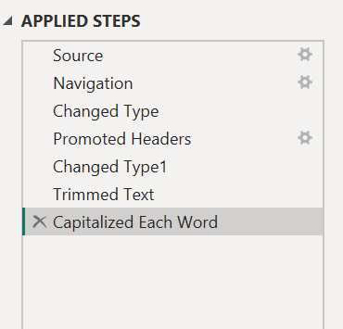
- Finally, I closed and applied. The table name was Sheet 1, so I renamed it as Employees_Data.

2.4 Products Data
- I got data from an Excel workbook, chose the Products table (Sheet 1) and opened it in Power Query.
- The column names and data types were correct. I only changed Unit Price from Whole Number to Decimal Number data type.

Issue 1: Duplicate row
- Issue Found: One duplicate row was found.
- Affected Table/Column: Products – all columns.
- Action Taken: I went to the Home tab and used Remove Rows → Remove Bottom Rows with number of rows as 1.
- Reason/Assumption: The row was repeated.
- Final Decision: Removed
Issue 2: Product Name and Category formatting
- Issue Found: Product names and category names were not in a clean format.
- Affected Table/Column: Products – Product Name, Category.
- Action Taken: I used Trim and Capitalize Each Word on both columns.
- Reason/Assumption: To keep the text consistent.
- Final Decision: Corrected
Issue 3: Null Category for Table Fan
- Issue Found: There was a null value in Category for the product Table Fan.
- Affected Table/Column: Products – Category.
- Action Taken: I filtered the product and saw there is only one Table Fan. I used Replace Values to replace the null with Electronics.
- Reason/Assumption: I assumed Table Fan belongs to the Electronics category.
- Final Decision: Corrected
Issue 4: Null Unit Price for Laptop Stand
- Issue Found: There was a null value in Unit Price for Laptop Stand.
- Affected Table/Column: Products – Unit Price.
- Action Taken: I checked the Product ID in other tables like the Order Items data, found the unit price there, and replaced the null with that price.
- Reason/Assumption: The same product's price in Order Items is the correct price.
- Final Decision: Corrected
Issue 5: Status formatting
- Issue Found: Some Status values started with a small letter.
- Affected Table/Column: Products – Status.
- Action Taken: I used Capitalize Each Word.
- Reason/Assumption: To keep the values consistent.
- Final Decision: Corrected
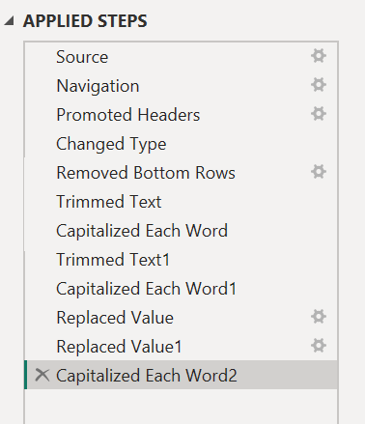
- Finally, I closed and loaded the data and renamed Sheet 1 as Products_Data.

2.5 Orders Data
I cleaned the Orders table in Excel first. The Order IDs were correct, but I sorted them in ascending order.
Issue 1: Wrong date
- Issue Found: One date became an error because the month and day were swapped.
- Affected Table/Column: Orders – Order Date.
- Action Taken: I used Text to Columns and filtered the wrong value. I changed the month to day and day to month. Only one date was wrong. After removing the filter, all dates were correct, and I pasted them as values.
- Reason/Assumption: The date was entered in the wrong order, so I swapped them.
- Final Decision: Corrected
Issue 2: Customer ID format
- Issue Found: The Customer IDs had extra spaces and were not in number format.
- Affected Table/Column: Orders – Customer ID.
- Action Taken: I trimmed the Customer IDs, converted them into numbers and replaced the old values.
- Reason/Assumption: Customer ID should be a number so it can match the Customers table.
- Final Decision: Corrected
Issue 3: Blank Customer IDs
- Issue Found: There were 4 blank cells in Customer ID.
- Affected Table/Column: Orders – Customer ID.
- Action Taken: I left them blank.
- Reason/Assumption: If I delete these rows, I will lose the data of the number of orders.
- Final Decision: Retained
Issue 4: Blank Salesperson IDs
- Issue Found: There were 2 blank cells in Salesperson ID.
- Affected Table/Column: Orders – Salesperson ID.
- Action Taken: I left them as empty cells.
- Reason/Assumption: I did not want to delete the orders or guess the salesperson.
- Final Decision: Retained
Issue 5: Duplicate Order ID
- Issue Found: Order ID 50015 had two duplicate rows.
- Affected Table/Column: Orders – Order ID.
- Action Taken: I removed one row.
- Reason/Assumption: The same order was repeated.
- Final Decision: Removed
Saving and loading the Orders data into PostgreSQL
- I saved the Orders sheet as an Orders CSV file.
- I opened PostgreSQL (pgAdmin) and created a database called sales_db.
- I went to sales_db → Schemas → Tables and opened the Query Tool. I typed:
CREATE TABLE orders(
order_id INT,
order_date DATE,
customer_id INT,
salesperson_id TEXT
);
- I went back to the left pane, refreshed Tables, and went to the orders table. I used Import and selected the CSV file. I set Header to Yes and Delimiter to comma (,), then clicked OK.
- The Orders CSV file was imported successfully into PostgreSQL.
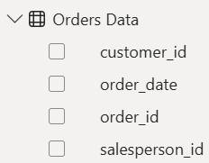

2.6 Order Items Data
- In Order Items, I saw there were many repeated Order IDs. I understood that one order can have multiple products.
- I sorted the OrderItem ID so the data looks better.
Issue 1: Duplicate OrderItem ID
- Issue Found: There was one duplicate row.
- Affected Table/Column: Order Items – OrderItem ID.
- Action Taken: I checked every column for duplicates. For OrderItem ID, I used Conditional Formatting → Highlight Cells → Duplicate Values and found one duplicate row. I removed it.
- Reason/Assumption: The same order item was repeated.
- Final Decision: Removed
Issue 2: Blank Product ID
- Issue Found: One blank value in Product ID.
- Affected Table/Column: Order Items – Product ID.
- Action Taken: I checked every column using Filter for blanks and found this one. I checked the other data but could not find the correct product, so I left it blank.
- Reason/Assumption: I did not want to guess the product.
- Final Decision: Retained
Issue 3: Zero quantity
- Issue Found: Two rows have quantity 0.
- Affected Table/Column: Order Items – Quantity, Revenue.
- Action Taken: In the first row, the quantity is 0 but the revenue is 799. I did not want to assume anything, so I left it as it is. In the second row, the quantity is 0 with unit price 1299 and the revenue is 0. I think this is because of a cancellation. I left both rows as they are.
- Reason/Assumption: I did not want to assume values. I assumed the second row is a cancelled order.
- Final Decision: Retained
- I saved the Order Items data as an Order Items CSV file because PostgreSQL can import only CSV files.
- I opened PostgreSQL and created a table in the sales_db database with this query:
CREATE TABLE order_items(
order_item_id INT,
order_id INT,
product_id INT,
quantity INT,
unit_price NUMERIC(10,2),
revenue NUMERIC(10,2)
);
- The query ran successfully.
- I imported the order_items CSV file and it was imported successfully.
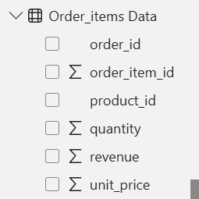

2.7 Loading the PostgreSQL Tables into Power BI
- First, I viewed the tables in pgAdmin. They were in the correct order.
- I opened Power BI and went to Get Data → searched for PostgreSQL → opened PostgreSQL Database → clicked Connect.
- A box popped up. I entered Server as localhost:5432 and Database as sales_db, selected Import, and clicked OK.
- I selected public.order_items and public.orders and opened them in Transform Data (Power Query).
- There were no errors because I had already done all the cleaning in Excel before importing into PostgreSQL.
- I only checked the data types in both tables. All were correct, so I did not need to apply any extra steps.
- I clicked Close & Apply (Load and Apply).
- After applying, I renamed public.order_items and public.orders as Orderitems Data and Orders Data.
- In Table view, the order_items ID was not in order, so I sorted it in ascending order. It was already in order in Power Query.
- I checked all the tables and they were good.

3. Day 2 – Phase 2: Data Model

3.1 Creating Relationships
- I wanted to create relationships between the tables.
- I opened Model View. The relationships were already created. I only arranged the tables in the correct order and connected Employees Employee ID with Orders Salesperson ID as 1 : * (one to many).
- The model looks like a star schema:
  - One customer can place many orders.
  - One order can have many items.
  - One product can be ordered many times.
  - One employee can sell many orders.
- I fixed the relationships between the tables and checked all the dimension keys.
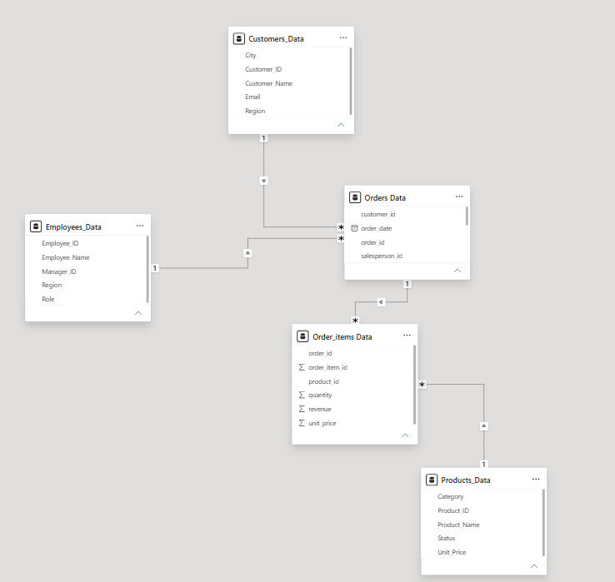

3.2 Creating the Calendar Table
- I went to Report View → Modeling tab → New Table. In the formula bar I entered:
Calendar = CALENDAR(MIN('Orders Data'[order_date]),MAX('Orders Data'[order_date]))
- This created a Calendar table, which is now visible in the Data pane.
- This gives a Date column. From it I added more columns. I right-clicked the Calendar table, selected New Column, and entered these in the formula bar:
  - Year = YEAR('Calendar'[Date])
  - Month Number = MONTH('Calendar'[Date])
  - Month Name = FORMAT('Calendar'[Date],"MMMM")
  - Quarter = "Qtr" & FORMAT('Calendar'[Date],"Q")
  - Day = DAY('Calendar'[Date])
- All the columns were added to the Calendar table.
- Then I marked it as a date table. In the Data pane I selected Calendar → Table Tools → Mark as Date Table (On), chose the Date column and clicked Save. This tells Power BI how to treat the table.
- In Model View, I saw the Calendar table had no relationship. I connected it to the Orders table using the order date, because it is common in both tables. In one date, many orders can be placed, so I created a 1 : * (one to many) relationship between Calendar and Orders. This controls the time-based calculations.
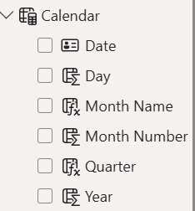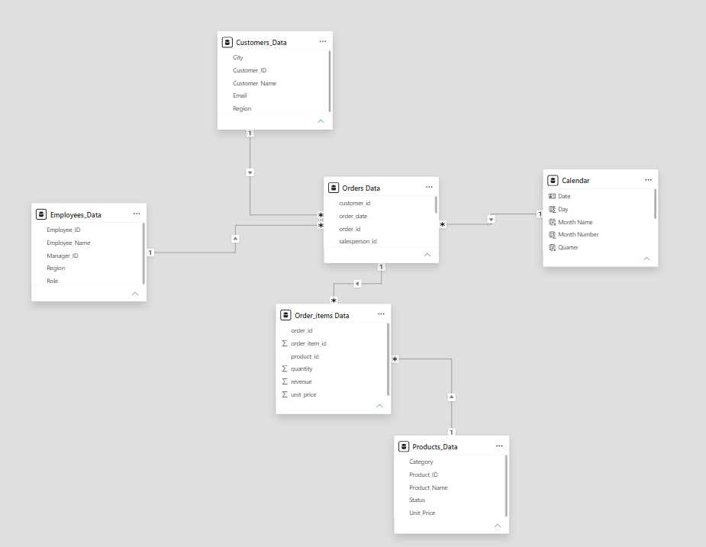

3.3 Testing the Model
- I created a simple visual to test whether all the tables are correct and whether the dimension tables filter the fact tables.
- The fact tables are Order Items and Orders. The dimension tables are Employees, Products, Customers and Calendar.
- I added one Card on report page 1 and added Revenue from Order Items. Then I added a Slicer and inserted Month Name, but the months were not in order. I went to the Calendar table, selected the Month Name column → Column Tools → Sort by Column → Month Number. The months changed into the correct order.
- The revenue changed when I filtered the months, so it is working.
- I also checked with Products and it works correctly.

4. Day 2 – Phase 3: DAX Requirements
I created the following measures:
- Total Revenue = SUM('Order_items Data'[revenue])
- Order Count = COUNT('Orders Data'[order_id]) or COUNTROWS('Orders Data')
- Average Order Revenue = AVERAGE('Order_items Data'[revenue])
- Total Quantity = SUM('Order_items Data'[quantity])
- Revenue Per Order = DIVIDE([Total Revenue],[Order Count])
- South Revenue = CALCULATE([Total Revenue],Customers_Data[Region]="South")
- High Value Revenue = CALCULATE([Total Revenue],FILTER('Order_items Data','Order_items Data'[revenue]>3000))
- Company Revenue = CALCULATE([Total Revenue],ALL(Customers_Data[Region]))
  - When I insert a Region slicer, every card changes except Company Revenue. It stays as the overall revenue of the company because the filter is removed.
- YTD Revenue = TOTALYTD([Total Revenue],'Calendar'[Date])
- Previous Month Revenue = CALCULATE([Total Revenue],DATEADD('Calendar'[Date],-1,MONTH))
- Sales LY = CALCULATE([Total Revenue],SAMEPERIODLASTYEAR('Calendar'[Date]))
  - When I insert this in a card it does not show any value, because our data has only one year. We do not have last year's data, so the card is blank (shows --).
- YOY Growth % = DIVIDE([Total Revenue]-[Sales LY],[Sales LY])
  - This has the same problem as Sales LY, because we need sales for two years, not one year.
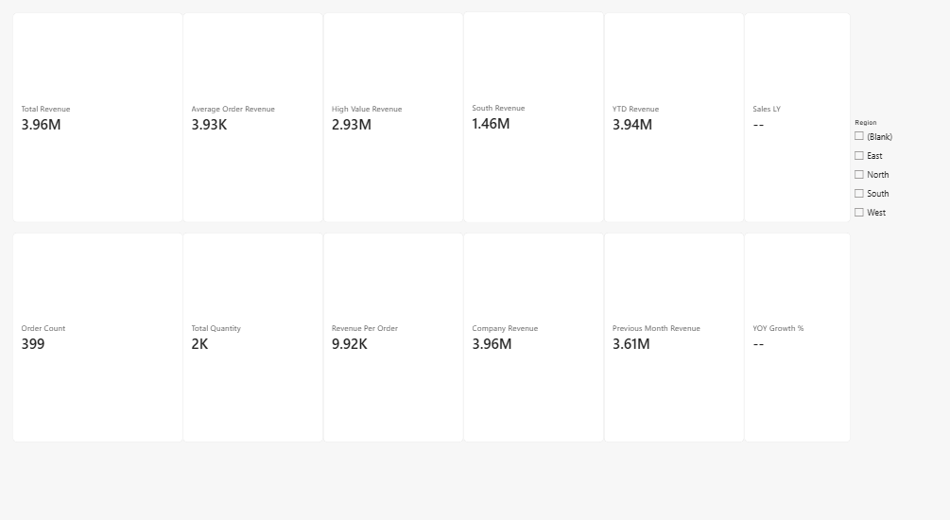

5. Day 2 – Phase 4: Report Requirements

Report 1 – Summary Page
- This is the summary page.
- I inserted four cards: Total Revenue, Order Count, Total Quantity and Revenue Per Order.
- I inserted a Line Chart for the monthly revenue trend.
  - X-axis: Months
  - Y-axis: Revenue
- I inserted a Stacked Column Chart for revenue by region.
  - X-axis: Region
  - Y-axis: Revenue
- I added two slicers: Region and Month Name.
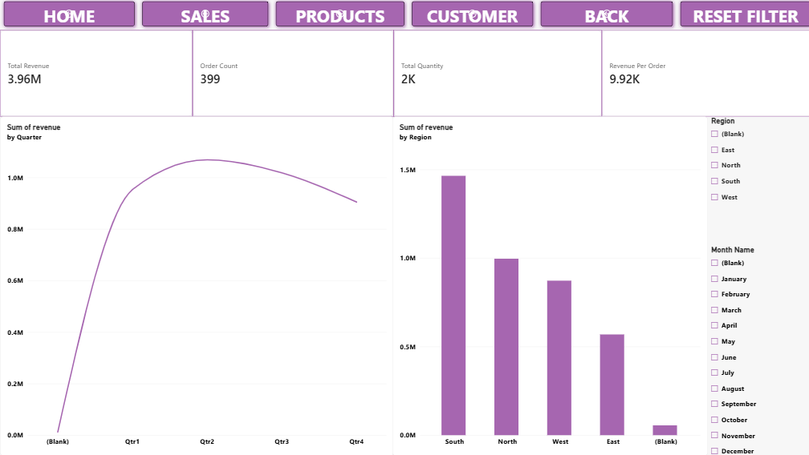

Report 2 – Sales Performance
- This page focuses on sales performance.
- I added a Bar Chart to show the salesperson performance.
  - X-axis: Revenue
  - Y-axis: Salesperson names
- I added revenue by region using a Funnel.
  - Category: Region
  - Values: Sum of Revenue
- I added revenue by month using a Line Chart.
  - X-axis: Region
  - Y-axis: Revenue
- I added three slicers to filter: Month Name, Region and Salesperson names.
- I added a customer names table, which helps to drill through to the Customers report.
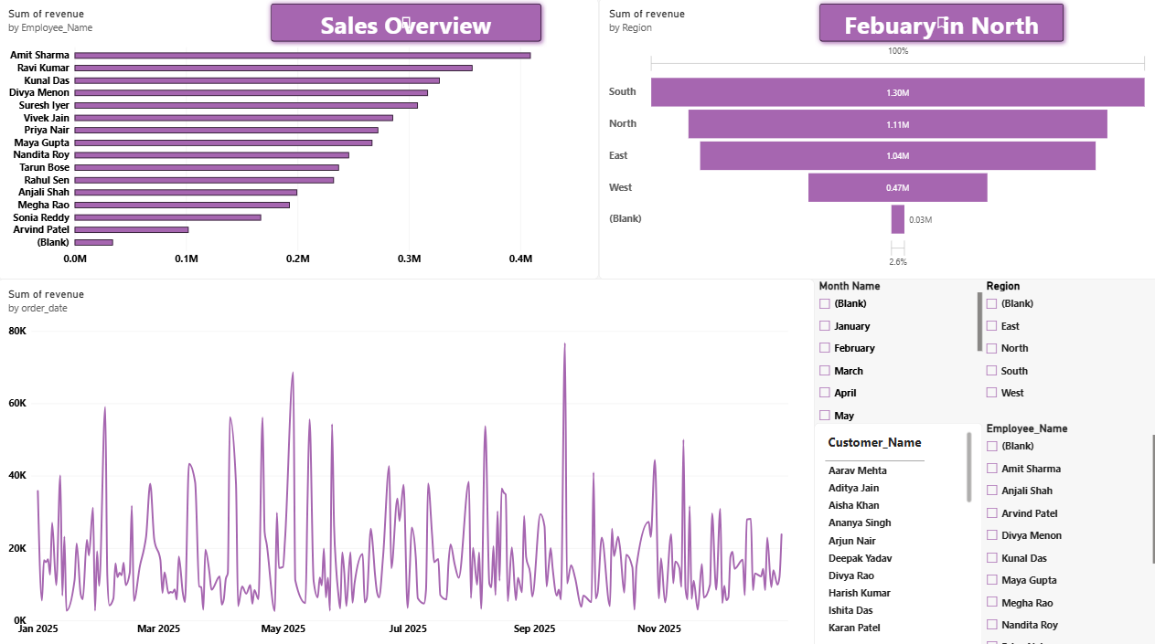

Report 3 – Product Analysis
- This report mainly focuses on product analysis.
- Revenue by product
  - Visual: Bar Chart
  - X-axis: Revenue
  - Y-axis: Product names
- Revenue by category
  - Visual: Column Chart
  - X-axis: Category
  - Y-axis: Revenue
- Quantity by category/product
  - Visual: Tree Map
  - Category: Category and Product name
  - Value: Sum of Revenue
  - I can use the drill-down arrows to see both. The up arrow is for category and the down arrow is for product names.
- I added slicers for Product names and Category.
- I compared the products/categories based on Revenue and Quantity to identify which products are performing better.
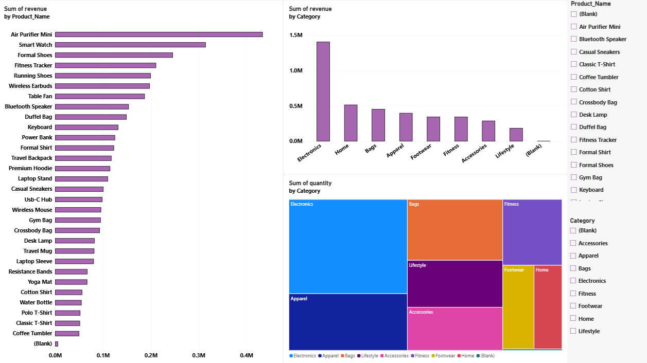

Report 4 – Customer Details
- The purpose of this page is to analyse individual customers and give detailed customer-level information.
- I used a Table visual with these fields from the Customers table:
  - Customer Name
  - Customer ID
  - Region
  - Order Count
  - Total Revenue
  - Total Quantity
  - Revenue Per Order
It gathers the information of every customer.
- Revenue by customer
  - Visual: Bar Chart
  - X-axis: Revenue
  - Y-axis: Customer names
  - This shows which customers generate more revenue.
- Customer region analysis
  - Visual: Donut Chart
  - Axis: Region
  - Values: Total Revenue
- I added two slicers: Region and Customer Name. This allows us to select a particular customer and see their details.
- I dragged the customer names to the Drill Through visual pane. A blue icon with an arrow appeared at the top left of the page. From the other report pages we can drill through to the Customers report.
- Page 4 gives customer-level analysis using revenue, orders, quantity and customer details, with drill-through for detailed customer analysis.
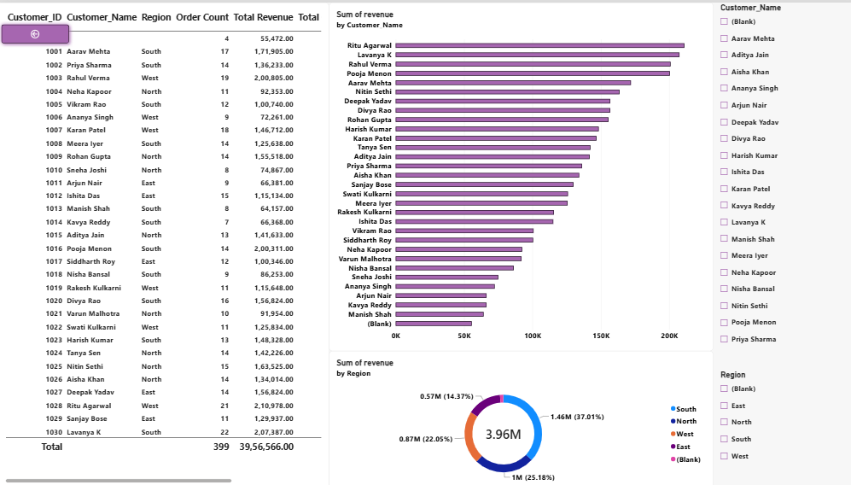

6. Day 3 – Interactivity Requirements

6.1 Slicers
I added slicers for Region, Month Names, Customer Names, Employee Names, Product Category and Product Names.

6.2 Date Hierarchy and Drill Down
- In my monthly trend Line Chart there were no years, quarters and months, which means the date hierarchy was missing.
- I removed Order Date from the X-axis and dragged Year, Quarter and Month Name from the Calendar table.
- Now the drill-down works. Before this, it was not showing.
6.3 Bookmarks
1. Created Sales Overview and Detailed Analysis bookmarks on the Sales Analysis page.
2. Selected February in the Month slicer and updated the detailed analysis bookmark.
3. Changed the slicer selection and updated the Sales overview bookmark.
4. Tested both bookmarks to check whether they restored the saved views.

6.4 Navigation Buttons
- I opened the Executive Overview page and went to Insert → Buttons → Blank.
- In the Visual pane I went to Style → Text and typed HOME. Then in Action I turned it On, set Type to Page Navigation and Destination to None.
- I copied the Home button, pasted it next to it and named it Sales. In Action, I set Type to Page Navigation and Destination to Sales Analysis.
- I copied the Sales button and changed the text to Products. I set Action → Page Navigation → Product Analysis.
- I copied it again and changed the text to Customers. I set Action → Page Navigation → Customer Details.
- I created a Back button using Insert → Buttons → Back. It gives the back button directly.
- I also created a button using Insert → Buttons → Blank with the text Reset Filters.
- To use these buttons in Power BI Desktop, I hold Ctrl and click on the button to go to the next page.

7. Row-Level Security (RLS)
- I did RLS (Row-Level Security) in Power BI Desktop.
- I created a manager role named North Manager:
  - I went to the Modeling tab → Manage Roles → Create.
  - I renamed the role as North Manager.
  - I selected the Customers table, selected the Region column and set the value as North.
  - I clicked Save.
- To check it, I went to View As, selected North Manager and clicked OK. Every report page showed only North region data.
- To exit, I went to the Modeling tab and clicked Stop Viewing.
- RLS Test Result: The North Manager role was tested using View As. The report displayed only data belonging to the North region, which confirms that the RLS filter was working correctly.
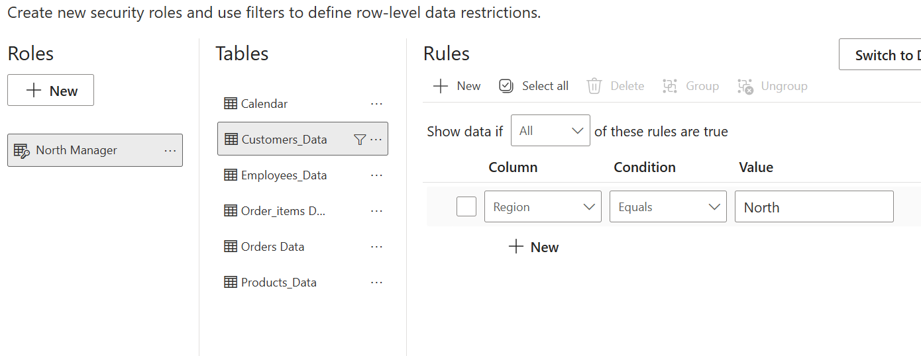

8. Power BI Service
- The report was prepared and is ready for publishing. Publishing to Power BI Service needs a Microsoft work or school account.
- I verified the following in Power BI Desktop:
  - Report pages and visuals
  - Slicers and filters
  - Drill-down and drill-through
  - Navigation buttons
  - DAX measures
  - Row-Level Security (RLS)
- The North Manager RLS role was tested using View As, and only North region data was displayed.
- Refresh: The report should be refreshed whenever the PostgreSQL data is updated. In Power BI Service we can set a schedule to refresh the data automatically. If PostgreSQL is running on a local computer, a gateway is needed for automatic refresh.
- Sharing and Workspace Permissions: In Power BI Service, the report should be shared only with the required users. Workspace permissions should be given based on the user's role, such as Viewer, Contributor, Member or Admin. RLS roles should be assigned to the proper users or groups to control access to the data.
- Demonstration of the Report: I demonstrated the completed report in Power BI Desktop by checking the report pages, visuals, slicers, drill-down, drill-through, navigation buttons, DAX measures and RLS.
- Note: I could not publish or demonstrate the report in Power BI Service because I did not have a Microsoft work or school account.

9. Management Summary
The dashboard shows a total revenue of 3.96M from 399 orders and 2,058 units sold. The South region has the highest revenue, and Electronics is the best-performing category. Air Purifier Mini is the top revenue-generating product. Sales are highest around Q2, with some fluctuations throughout the year.

10. Recommendations
- Focus more on Electronics and top-selling products.
- Maintain enough stock for high-demand products.
- Improve sales in the lower-performing regions.
- Study the sales fluctuations to identify high-performing periods.
- Use successful employees and customers as examples to improve overall sales.

11. Business Questions to Answer
• What is total revenue?
• How many orders are there?
• What is the average revenue per order?
• Which region performs best?
• Which products/categories generate the most revenue?
• Which salesperson performs best?
• Who are the top customers?
• Which month has the highest revenue?
• What is the YTD revenue?
• What happens to KPIs when Region is filtered?
• What is High Value Revenue?
• Why may Sales LY / YoY Growth not provide a meaningful result with this dataset?
• What does the North Manager see under RLS?

